Vitamin D Status and Glycemic Control in Patients with Type 2 Diabetes Mellitus in Najaf: A Cross-Sectional Study [12 pt, Bold – title]
Ali Hussein Al-Amiri^{1*}, Zahraa Kadhim Al-Musawi², Hasan Abbas Al-Jubouri³ [11 pt – authors]
¹Department of Internal Medicine, College of Medicine; ²Department of Clinical Biochemistry, College of Pharmacy; ³Department of Community Medicine, College of Medicine, Jabir ibn Hayyan University for Medical and Pharmaceutical Sciences, Najaf, Iraq [10 pt – affiliations]
* Corresponding author e-mail: corresponding.author@jmu.edu.iq
Received: dd/mm/yyyy; Revised: dd/mm/yyyy; Accepted: dd/mm/yyyy (SAMPLE ARTICLE – fictional authors and illustrative data for template purposes) [9 pt – completed by JMJ]

Abstract [12 pt, Bold – heading]
Vitamin D deficiency has been linked to insulin resistance and impaired glycemic control. This cross-sectional study evaluated serum 25-hydroxyvitamin D concentrations and glycated hemoglobin in 200 adults with type 2 diabetes mellitus attending the diabetes outpatient clinic of a teaching hospital in Najaf, Iraq, between January and June 2025. Participants were classified as vitamin D deficient (< 50 nmol/L), insufficient (50–74 nmol/L) or sufficient (≥ 75 nmol/L). Half of the participants (50.0%) were deficient. Mean glycated hemoglobin was 8.6 ± 0.14% in deficient, 7.9 ± 0.17% in insufficient and 7.3 ± 0.15% in sufficient participants (P < 0.001), and poor glycemic control (glycated hemoglobin ≥ 7.0%) was found in 78.0%, 60.0% and 42.2% of the three groups, respectively. Vitamin D deficiency was common and associated with poorer glycemic control, supporting routine assessment of vitamin D status in patients with type 2 diabetes. [11 pt – abstract text]
Keywords: Vitamin D, Type 2 diabetes mellitus, Glycated hemoglobin, Insulin resistance, Najaf [11 pt – keywords]

حالة فيتامين د والسيطرة على سكر الدم لدى مرضى داء السكري من النوع الثاني في النجف: دراسة مقطعية [12 pt, Bold – Arabic title]
علي حسين العامري: فرع الطب الباطني/ كلية الطب/ جامعة جابر بن حيان للعلوم الطبية والصيدلانية/ النجف - العراق
زهراء كاظم الموسوي: فرع الكيمياء الحياتية السريرية/ كلية الصيدلة/ جامعة جابر بن حيان للعلوم الطبية والصيدلانية/ النجف - العراق
حسن عباس الجبوري: فرع طب المجتمع/ كلية الطب/ جامعة جابر بن حيان للعلوم الطبية والصيدلانية/ النجف - العراق
الخلاصة [12 pt, Bold – heading]
ارتبط نقص فيتامين د بمقاومة الأنسولين وضعف السيطرة على سكر الدم. قيّمت هذه الدراسة المقطعية تركيز 25-هيدروكسي فيتامين د والهيموغلوبين السكري لدى 200 مريض بالغ بداء السكري من النوع الثاني في عيادة السكري الاستشارية لمستشفى تعليمي في النجف خلال المدة من كانون الثاني إلى حزيران 2025. كان نصف المرضى (50.0%) مصابين بنقص فيتامين د، وبلغ متوسط الهيموغلوبين السكري 8.6% و7.9% و7.3% في مجموعات النقص والقصور والكفاية على التوالي، وكانت نسبة ضعف السيطرة على سكر الدم 78.0% و60.0% و42.2% على التوالي. يُستنتج أن نقص فيتامين د شائع ويرتبط بضعف السيطرة على سكر الدم، مما يدعم التقييم الروتيني لحالة فيتامين د لدى هؤلاء المرضى.

- Introduction [12 pt, Bold – heading]
Type 2 diabetes mellitus (T2DM) is a chronic metabolic disorder characterized by hyperglycemia resulting from insulin resistance and progressive β-cell dysfunction (1). [11 pt – main text]
The global burden of diabetes continues to rise; an estimated 537 million adults aged 20–79 years were living with diabetes in 2021, and the number is projected to increase substantially by 2045, with a large share in low- and middle-income countries including the Middle East (2).
Beyond its classical role in calcium and bone metabolism, vitamin D has been implicated in glucose homeostasis (3,4). Vitamin D may influence glycemic control through two main mechanisms:
- By enhancing insulin secretion through vitamin D receptors and calcium-dependent signaling in pancreatic β-cells (4).
- By reducing systemic inflammation and improving peripheral insulin sensitivity in muscle and adipose tissue (4).
However, randomized trials of vitamin D supplementation have produced inconsistent results for the prevention and control of T2DM (5).
Vitamin D deficiency is highly prevalent in the Middle East despite abundant sunshine, owing to limited sun exposure, skin coverage and dietary factors (6). Vitamin D status is usually assessed by serum 25-hydroxyvitamin D [25(OH)D] concentration (7).
This study was conducted at Jabir ibn Hayyan University for Medical and Pharmaceutical Sciences to evaluate the relationship between vitamin D status and glycemic control in adults with T2DM in Najaf.

- Materials and Methods [12 pt, Bold – heading]
A cross-sectional study was conducted at the diabetes outpatient clinic of a teaching hospital in Najaf, Iraq, from January to June 2025. Adults aged 30–70 years with T2DM for at least one year were enrolled consecutively. Patients receiving vitamin D or calcium supplements and those with chronic kidney or liver disease were excluded. The study was approved by the Ethics Committee of the College of Medicine (approval no. [….]), and written informed consent was obtained from all participants.
Serum 25(OH)D was measured by electrochemiluminescence immunoassay; vitamin D status was classified as deficient (< 50 nmol/L), insufficient (50–74 nmol/L) or sufficient (≥ 75 nmol/L) (7). Glycated hemoglobin (HbA1c) was measured by high-performance liquid chromatography, and HbA1c ≥ 7.0% was considered poor glycemic control (1). Data were analyzed using SPSS version 26; results are presented as mean ± standard error (SE), and groups were compared using one-way analysis of variance and the chi-square test. P < 0.05 was considered significant.
- Results and Discussion [12 pt, Bold – heading]
A total of 200 patients (mean age 54.6 years) were included. Vitamin D deficiency was found in 100 patients (50.0%), insufficiency in 55 (27.5%) and sufficiency in 45 (22.5%). Mean HbA1c decreased progressively from the deficient to the sufficient group (Figure 1).
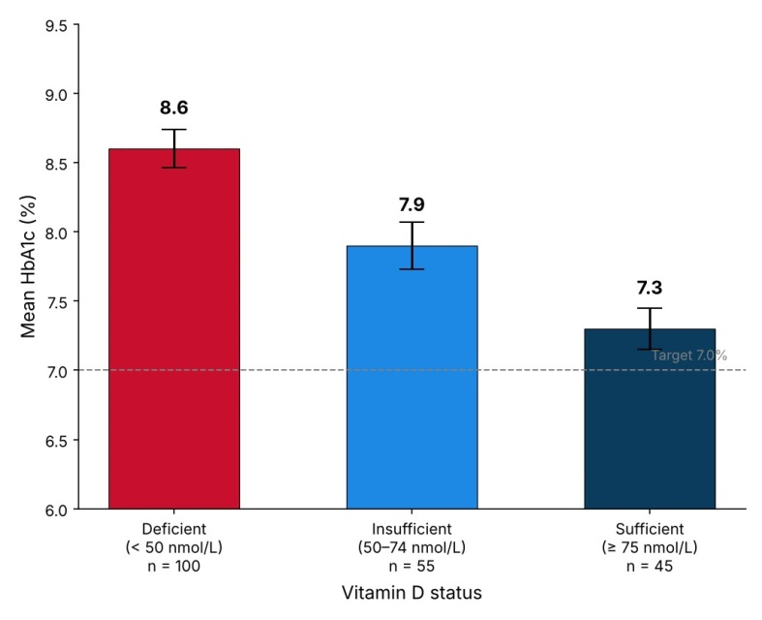

Figure 1: Mean glycated hemoglobin (HbA1c, %) according to vitamin D status (error bars: standard error) [11 pt, Bold – table/figure title]

Table 1 shows the distribution of participants by age group and vitamin D status. Deficiency was most frequent in patients aged 50–59 years.
Poor glycemic control (HbA1c ≥ 7.0%) was significantly more frequent among vitamin D deficient patients (78.0%) than among insufficient (60.0%) and sufficient (42.2%) patients (P < 0.001) (Table 2).

Table 1: Distribution of patients with type 2 diabetes mellitus by age group and vitamin D status (n = 200)
Age group (years) [10 pt – table text] | Vitamin D status (n) |  |  | Total (n)
Age group (years) [10 pt – table text] | Deficient | Insufficient | Sufficient | Total (n)
30–39  40–49  50–59  60–70 | 10  22  38  30 | 8  15  20  12 | 7  13  17  8 | 25  50  75  50

Table 2: Glycemic control according to vitamin D status in patients with type 2 diabetes mellitus
Vitamin D status | Patients (n) | HbA1c ≥ 7.0% (n) | Proportion (%)
Deficient  Insufficient  Sufficient  Total | 100  55  45  200 | 78  33  19  130 | 78.0  60.0  42.2  65.0

The present findings indicate an inverse association between vitamin D status and glycemic control, in agreement with the proposed effects of vitamin D on insulin secretion and insulin sensitivity (3,4). The high prevalence of deficiency is consistent with previous reports from the Middle East (6).
Although supplementation trials have not consistently shown glycemic benefit (5), correcting deficiency remains clinically relevant because of its skeletal and possible metabolic effects.
Improving glycemic control is important, as intensive glucose control has been shown to reduce microvascular complications in patients with T2DM (8).
This study has limitations: its cross-sectional design does not allow causal inference, seasonal variation in vitamin D was not assessed, and potential confounders such as physical activity, sun exposure and diet were not fully controlled.
Table 3 shows the mean HbA1c and fasting plasma glucose in each group. Both parameters were highest in the deficient group and lowest in the sufficient group (P < 0.001).
No significant differences in age or sex distribution were observed between the three groups.
Conclusions [12 pt, Bold – heading]
Vitamin D deficiency is common among patients with T2DM in Najaf and is associated with poorer glycemic control. Routine assessment of vitamin D status may be considered in diabetes care, and prospective studies are needed to clarify causality.
Table 3: Glycated hemoglobin and fasting plasma glucose according to vitamin D status (mean ± SE)
Vitamin D status | Patients (n) | HbA1c (%) mean ± SE | Fasting plasma glucose (mmol/L) mean ± SE
Deficient  Insufficient  Sufficient  Total | 100  55  45  200 | 8.6 ± 0.14  7.9 ± 0.17  7.3 ± 0.15  8.1 ± 0.10 | 10.2 ± 0.25  9.1 ± 0.28  8.0 ± 0.24  9.4 ± 0.16

Acknowledgment [12 pt, Bold – heading]
The authors thank the staff of the diabetes outpatient clinic and the laboratory of Jabir ibn Hayyan University for Medical and Pharmaceutical Sciences for their help with data collection.
References [12 pt, Bold – heading]
1. American Diabetes Association Professional Practice Committee. 2. Diagnosis and classification of diabetes: Standards of Care in Diabetes—2024. Diabetes Care. 2024;47(Suppl 1):S20–42. https://doi.org/10.2337/dc24-S002 [11 pt – references]
2. Sun H, Saeedi P, Karuranga S, Pinkepank M, Ogurtsova K, Duncan BB, et al. IDF Diabetes Atlas: global, regional and country-level diabetes prevalence estimates for 2021 and projections for 2045. Diabetes Res Clin Pract. 2022;183:109119. https://doi.org/10.1016/j.diabres.2021.109119
3. Holick MF. Vitamin D deficiency. N Engl J Med. 2007;357(3):266–81. https://doi.org/10.1056/NEJMra070553
4. Mitri J, Pittas AG. Vitamin D and diabetes. Endocrinol Metab Clin North Am. 2014;43(1):205–32.
5. Pittas AG, Dawson-Hughes B, Sheehan P, Ware JH, Knowler WC, Aroda VR, et al. Vitamin D supplementation and prevention of type 2 diabetes. N Engl J Med. 2019;381(6):520–30. https://doi.org/10.1056/NEJMoa1900906
6. Lips P. Worldwide status of vitamin D nutrition. J Steroid Biochem Mol Biol. 2010;121(1–2):297–300.
7. Holick MF, Binkley NC, Bischoff-Ferrari HA, Gordon CM, Hanley DA, Heaney RP, et al. Evaluation, treatment, and prevention of vitamin D deficiency: an Endocrine Society clinical practice guideline. J Clin Endocrinol Metab. 2011;96(7):1911–30. https://doi.org/10.1210/jc.2011-0385
8. UK Prospective Diabetes Study (UKPDS) Group. Intensive blood-glucose control with sulphonylureas or insulin compared with conventional treatment and risk of complications in patients with type 2 diabetes (UKPDS 33). Lancet. 1998;352(9131):837–53. https://doi.org/10.1016/S0140-6736(98)07019-6

